Cloud Security Incident Management

Table of Contents

1-Introduction

2-Cloud Security Vulnerabilities

2.1-cloud vulnerabilities

2.2-cloud environment assessment

3-incident response plan

3.1-The purpose of this plan

3.2-Cloud Infrastructure Overview

3.3-Security Measures

3.4-Monitoring and Logging

3.5-Security Controls

3.6-Incident examples

3.7-Incident Response Phases

3.8-Communication Plan

3.9-Post-Incident Activities

4-Cloud Environments Communication and Escalation Protocols

4.1-Communication Channels

4.2-Escalation Tiers

4.3-Incident Severity

4.4-Post-Incident Communication

5-Business continuity and disaster recovery plan for cloud environments

5.1-Business Impact Analysis (BIA)

5.2-. Cloud Risk Assessment

5.3-Continuity Strategy

5.4-Backup and Replication

5.5-Communication Plan

6-Disaster recovery (DR)

6.1-Disaster Recovery Objectives

6.2-DR Infrastructure

6.3-Recovery Procedures

6.4-Security Considerations

6.5-Compliance and Legal Requirements

6.6-Monitoring and Maintenance

6.7-Plan Testing and Training

**1- Introduction:**

This report outlines the findings and strategies developed during the "Cloud Security Incident Management" project, focusing on cloud-specific vulnerabilities, incident response planning, and business continuity and disaster recovery strategies.

**2-Cloud Security Vulnerabilities**

**2.1- Common Vulnerabilities in Cloud Environments**

1. Misconfigured Cloud Services

Misconfigurations, such as open storage buckets or insecure firewall rules, often lead to unauthorized access or data exposure. Ensuring proper configurations and regular auditing services are essential.

2. Insecure APIs

APIs, vital for cloud service interactions, can be vulnerable if not properly secured. Issues like weak authentication, poor input validation, and lack of rate limiting can expose cloud environments to attacks like data breaches and denial-of-service (DoS).

3. Weak Identity and Access Management (IAM)

Poorly implemented IAM policies can grant excessive permissions, enabling privilege escalation and insider threats. Implementing least-privilege access and multi-factor authentication (MFA) is key.

4. Data Breaches

Insecure storage configurations, lack of encryption, and improper access control can lead to data leaks. Data should always be encrypted in transit and at rest, and access should be tightly controlled.

5. Vulnerable Containers and VMs

Cloud environments using containers or virtual machines (VMs) are susceptible to attacks through outdated images or hypervisor vulnerabilities, potentially leading to host system compromise.

6. Weak Encryption

Using deprecated encryption methods or mismanaging encryption keys can expose sensitive data. Always use strong, up-to-date encryption and proper key management practices.

7. Inadequate Monitoring

Without proper logging and monitoring, detecting and responding to cloud security incidents becomes difficult. Continuous monitoring and integration with security tools are critical.

8. Denial of Service (DoS) Attacks

Cloud services are targets for DoS attacks. Lack of robust protection can overwhelm resources, leading to service disruptions. Implementing DDoS protection is essential.

9. Shared Responsibility Model

Misunderstanding the shared responsibility model can lead to gaps in security. While cloud providers secure the infrastructure, customers must secure their applications, configurations, and data.

**2.2- Vulnerability Assessment on The Cloud Environment**

❖ Firstly create a cloud environment on the AWS platform

1-Set up the EC2 servers and create the VPC

2-Set up the internet gateway

3-Add security group and IAM rules

●Applying the least privilege for the users to maintain the concept of zero trust

●Multi-factor authentication for the users

4-Access the EC2 servers and install Apache web server

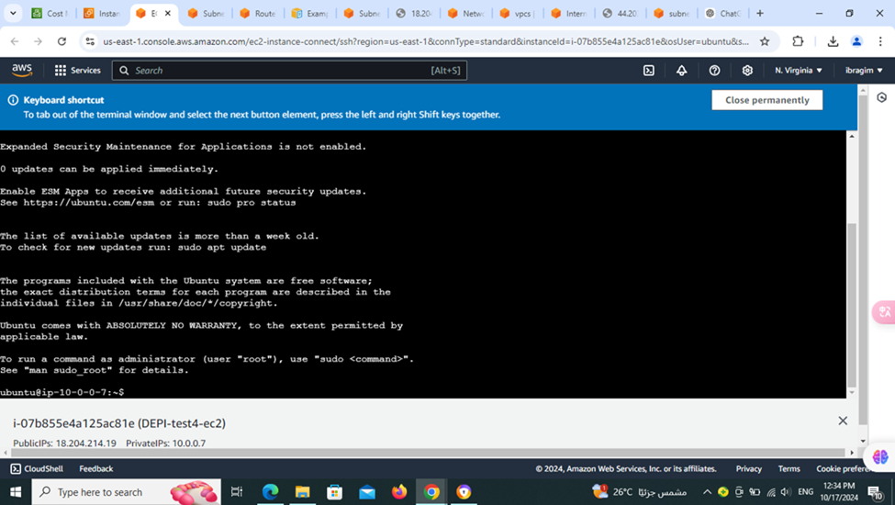

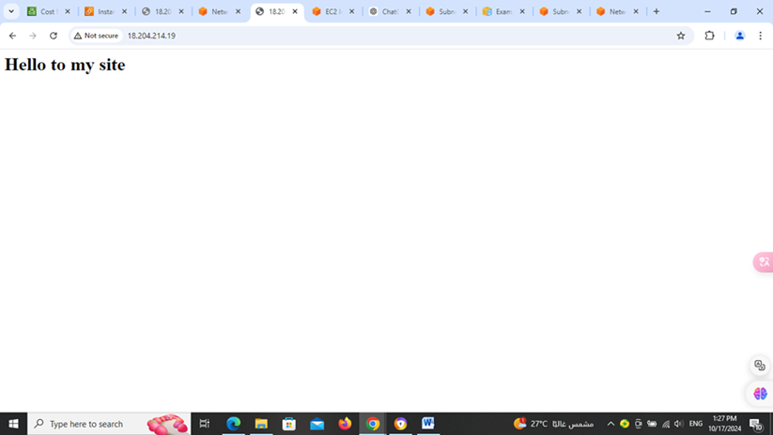

❖ Secondly setting up the monitoring tool and the log file

1- Set up CloudWatch tool

2- Set up the CloudAgent

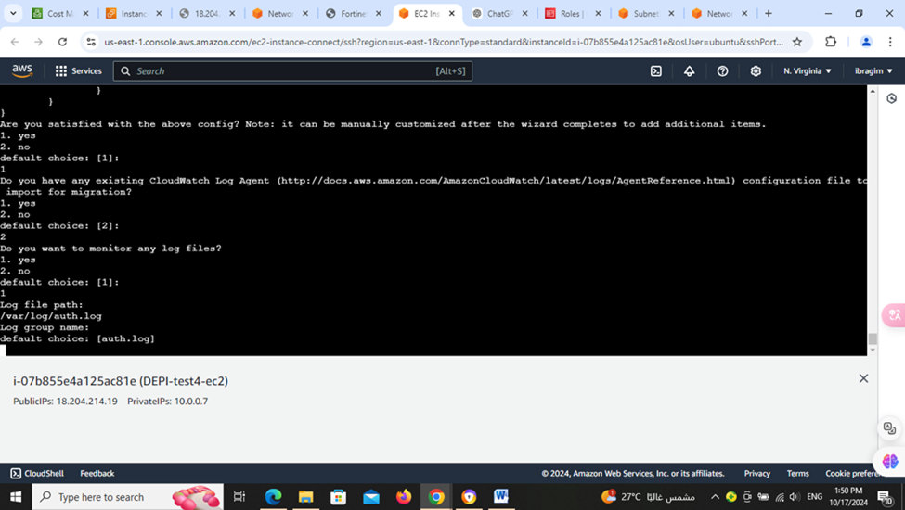

3-creating LogFile for storing the logs at the CloudWatch and monitoring it

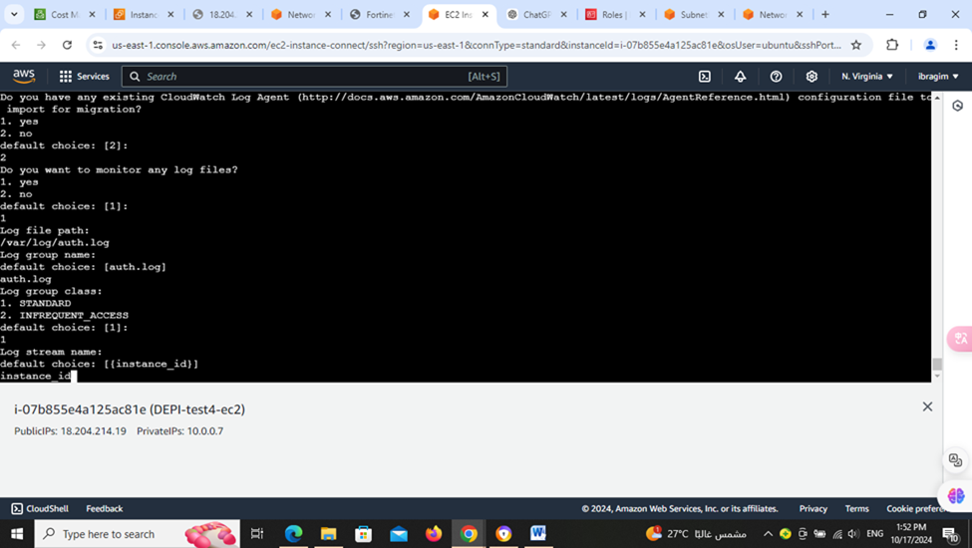

4- monitor the EC2 servers

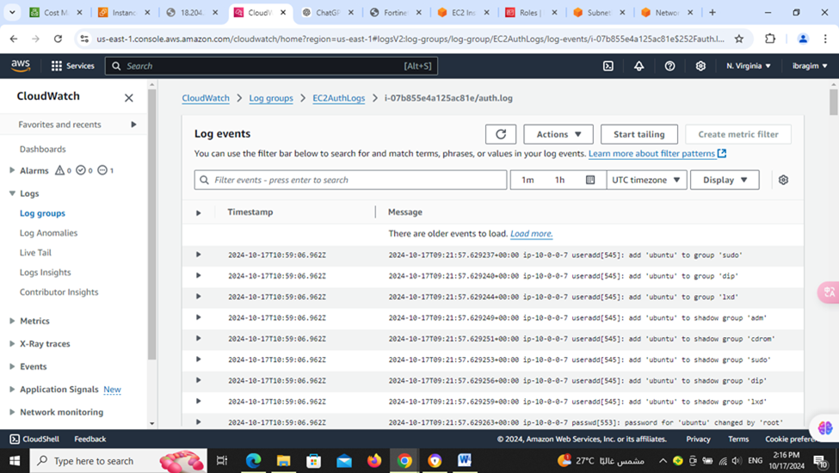

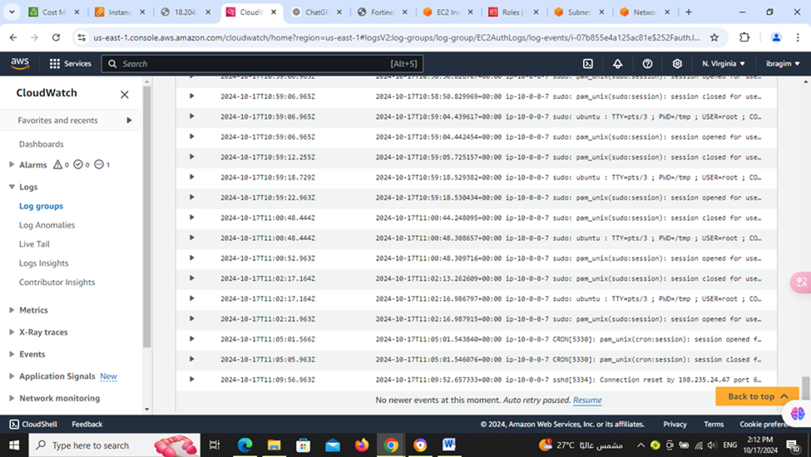

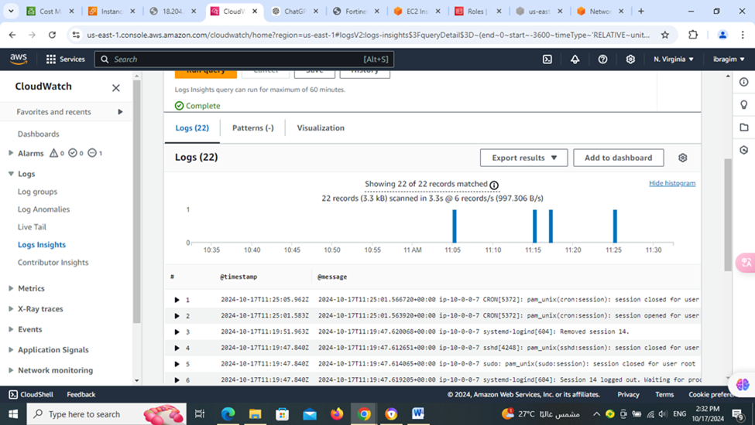

❖Thirdly make alarm and responding techniques during DDos attack

1- set up an alarm that detects the frequent accesses of the servers during definite intervals of time

2- creating metrics for making the specs of the alarm requirement to take actions

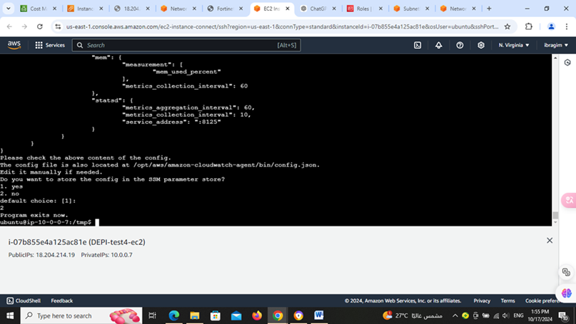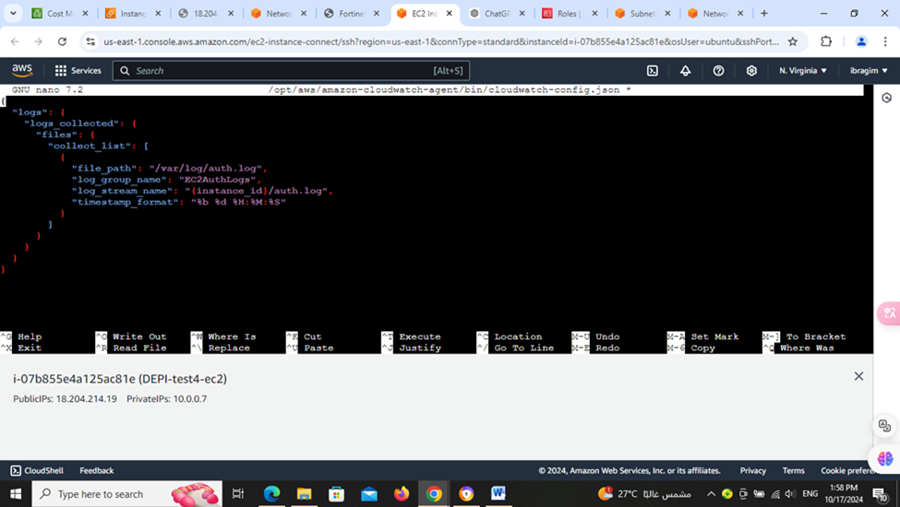

3- set up the SNS tool to send an alert if the cloud environment is

being attacked specially by Dos attack to alert us due to the

criticality of the Dos attack that can be a bridge for another

attacks

**3-Incident Response Plan**

**3.1-why We Need This Plan?**

The purpose of this plan is to help us know exactly what to do when something goes

wrong with our cloud systems, like a security issue or an attack. This way, we can fix

things quickly, minimize any damage, and get everything back to normal as soon as

possible

**3.2-Cloud Infrastructure Overview**

The organization’s cloud infrastructure is deployed across two AWS regions:

• Multi-Region Setup: Two AWS regions with Virtual Private Clouds, supporting redundancy and resilience.

• Public Subnets: Each VPC hosts 4 EC2 instances, resulting in 8 instances total to run the application.

• Private Subnets: Contains RDS (PostgreSQL) databases, configured with multi-AZ deployment for high availability

**3.3-Security Measures**

• Internet Gateway manages external traffic.

• Security Groups and Network ACLs control inbound and outbound traffic.

• Load Balancer – CloudFront provide content delivery and distribute traffic across instances.

• AWS WAF safeguards the application against common web exploits • AWS Shield mitigates Distributed Denial of Service (DDoS) attacks.

**3.4-Monitoring and Logging**

• AWS CloudWatch monitors CPU utilization, network traffic, and service health

. • VPC Flow Logs capture network traffic for analysis.

• CloudTrail tracks API calls and configuration changes.

• AWS Config monitors resource configurations for drift detection and compliance.

**3.5-Security Controls**

• IAM Roles – Policies enforce least privilege access

. • Multi-factor Authentication for all IAM users.

• Encryption at Rest and in transit for data stored in S3 and RDS databases.

• Automated patching ensures EC2 instances are regularly updated, enhancing network hardening.

**3.6-Who’s In Charge?**

• Incident Response Team Leader: Makes big decisions – coordinates everyone. • Cloud Security Analyst: Figure out issue – collect evidence – analyse the issue. • Cloud Administrator: Makes sure the cloud systems are running well again.

• Compliance Officer: Ensures we handle everything according to the law.

• Communications Officer: Telling the right people (customers – media) what’s going on, if necessary

**3.7-Incident examples:**

• Data Breach: Unauthorized access to sensitive information.

• Denial of Service (DoS) Attack: Hackers overwhelm our cloud servers to slow

it

• Account Compromise: Someone’s account gets hacked.

• Misconfiguration: Setting up the cloud systems incorrectly.

**3.8-Incident Response Phases**

**1st. Preparation**

• Conduct regular training for the IRT on cloud-specific threats.

• Ensure cloud systems have up-to-date monitoring and logging.

• Implement access controls and encryption to protect data.

**2nd. Detection and Analysis**

• Identify suspicious activity through cloud monitoring tools (e.g., AWS CloudTrail)

• Verify if the incident is genuine by cross-checking logs, alerts, and reports

. • Analyze the extent of the incident, affected systems, and potential data loss.

**3rd. Containment**

• Short-term Containment: Immediately isolate affected resources to prevent further damage (e.g., disconnect compromised VMs).

• Long-term Containment: Apply security patches, block malicious IPs, or reset passwords as needed.

**4th. Eradication**

• Identify root cause of the incident (e.g., vulnerability, malware, phishing attack).

• Remove all malicious artifacts (e.g., delete infected instances, remove malware).

• Harden the cloud environment to prevent recurrence (e.g., improve security configurations, patch vulnerabilities).

**5th. Recovery**

• Restore cloud services and data from backups (if required).

• Monitor systems closely to ensure normal operations are restored correctly

• Test the system to verify it's secure.

**6th. Lessons Learned**

• Conduct a post-incident review with the IRT.

• Document what went wrong, what went well, and areas for improvement.

• Update the incident response plan and security measures as needed.

**3.8-Communication Plan**

• Internal Communication: Notify relevant personnel within the organization about the incident.

• External Communication: Inform customers, stakeholders, and, if necessary, regulatory bodies about the breach while maintaining transparency.

**3.9-Post-Incident Activities**

• Review and Documentation: Complete a detailed report outlining the incident, response efforts, and future preventive measures.

• Training and Updates: Use the incident as a learning opportunity to update staff training and adjust security policies.

**4-Cloud Environments Communication and Escalation Protocols**

**4.1-Communication Channels:**

• Internal: Use platforms like Slack or Teams for real-time coordination.

• External: Notify clients, third-party vendors, and AWS Support as needed.

• Incident Reporting: Track incidents via AWS Security Hub or similar tools.

**4.2-Escalation Tiers:**

• Tier 1 (Low-Level Incidents): Minor issues handled by on-call DevOps. Escalate if unresolved within 30 minutes.

• Tier 2 (Medium-Level Incidents): Unauthorized access or performance issues. Escalate to the IRT lead or AWS Support if unresolved in 1 hour.

• Tier 3 (High-Level Incidents): Major breaches or outages. Immediate response from IRT, AWS Shield, and legal team; notify executives and stakeholders.

**4.3-Incident Severity:**

• P1 (Critical): Immediate action, executives notified within 15 minutes.

• P2 (High): Action within 30 minutes, escalate in 1 hour.

• P3 (Medium): Action within 1 hour, escalate in 4 hours.

• P4 (Low): Resolved within 24 hours, escalate if persistent.

**4.4-Post-Incident Communication:**

• Prepare reports

• Hold review meetings

• Notify clients

5-**Business continuity and disaster recovery plan for cloud environments.**

Business Continuity Plan (BCP):

➢ Ensures that critical operations can continue during and after a disaster.

**5.1-Business Impact Analysis (BIA)**

➢ Identify which business functions are critical and their dependencies in the cloud

➢ Helps prioritize recovery efforts based on the impact of disruptions.

**1 Identify Critical Functions**: list the applications, services, and processes that are essential for business operations.

**2 Determine Recovery Time Objective (RTO)**: Define the maximum acceptable downtime for each critical function.

**3 Determine Recovery Point Objective (RPO)**: Set the maximum amount of data loss measured in time

**5.2. Cloud Risk Assessment**

➢ Evaluate potential risks to cloud environments and how to address them.

**1 Identify Threats**: List possible risks; data loss, cloud provider outages, cyberattacks, or network failures.

**2 Evaluate Vulnerabilities**: Review how cloud systems may be exposed to these risks (e.g., weak encryption, unpatched software).

**3 Mitigation Strategies:** Implement preventive measures like multi-factor authentication, network security protocols, and encrypted backups.

**5.3. Continuity Strategy**

➢ Strategies to ensure business functions continue during and after disruptions.

**1 High Availability (HA)**: Design applications with redundancy across multiple availability zones or regions.

**2 Failover Systems**: Configure cloud infrastructure to automatically failover to another region if the primary one fails.

**3 Hybrid Cloud:** Use a hybrid approach by spreading critical workloads across both on-premises and cloud infrastructure for greater resilience.

**5.4. Backup and Replication**

➢ Ensure data is regularly backed up and available for recovery.

**1 Data Backups**: Set up regular, automated backups of critical data to a secure cloud storage location.

**2 Cross-Region Replication**: Replicate databases and storage across multiple regions to avoid single-point failures.

**3 Backup Validation**: Regularly test backup restoration to ensure data can be recovered successfully.

**5.5. Communication Plan**

➢ Create a plan for how to communicate during a disruption.

**1 Emergency Contacts**: Prepare a contact list of cloud providers, IT staff, and key stakeholders.

**2 Notification Procedures**: Define how to communicate with the team and stakeholders during a disruption.

**3 Crisis Management Team (CMT**): Assign roles and responsibilities to decision-makers and technical personnel in charge of activating and managing the BCP.

**6-Disaster recovery (DR)**

➢ Focuses on restoring data and services

**6.1. Disaster Recovery Objectives**

**1 Set Recovery Goals**: Make sure DR plan aligns with the RTO and RPO for all key systems and data.

**2 Determine DR Site**: Use cloud-based DR infrastructure in another region or a different cloud provider.

**6.2. DR Infrastructure**

1 **Cloud DR Setup**: Use Disaster Recovery as a Service (DRaaS) to automate the recovery process. DRaaS replicates data and infrastructure and handles failover during a disaster.

2 **Geographical Redundancy**: Ensure that key services are duplicated in other regions to avoid regional failures.

3 **Auto-Scaling and Load Balancing**: Use cloud-based auto-scaling and load balancers to handle recovery and scaling during high-demand situations

**6.3. Recovery Procedures**

**1 Detailed Restoration Plan:** Create a guide to restore services, from activating backups to reconfiguring cloud services.

**2 Automated Recovery:** Use tools like AWS CloudFormation or Azure Automation to redeploy cloud infrastructure in case of failure.

**3 Testing**: Regularly conduct disaster recovery tests to ensure the plan works and staff are familiar with it

**6.4. Security Considerations**

**1 Data Encryption**: Make sure that data is encrypted at rest and in transit.

**2 Access Management:** Enforce controls over who can access recovery systems.

**3 Incident Response**: Align DR plan with cybersecurity incident response to handle data breaches or other attacks.

**6.5. Compliance and Legal Requirements**

**1 Regulatory Compliance:** Ensure the plan complies with regulations like HIPAA or GDPR regarding data protection and recovery.

**2 Data Residency:** Make sure replication across regions follows local data residency laws.

**6.6. Monitoring and Maintenance**

**1 Cloud Monitoring**: Use cloud monitoring tools (like AWS CloudWatch or Azure Monitor) to detect issues early.

**2 Plan Updates**: Regularly review and update the BCP and DR strategy as the cloud environment or business needs change.

**3 Service Level Agreements (SLAs)**: Keep an eye on cloud provider SLAs to ensure they meet your business’s recovery needs.

**6.7. Plan Testing and Training**

**1 Simulate Failures**: Run regular drills to simulate outages and check effectiveness of the BCP and DR plans.

**2 Employee Training**: Make sure staff are trained on their roles in executing the BCP and DR plan.

**3 Post-Test Review**: After each test, evaluate what worked and what didn’t, and adjust the plan as needed.